


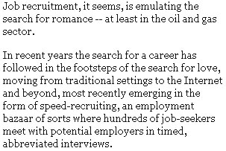

In recent years the search for a career has followed in the footsteps of the search for love, moving from traditional settings to the Internet and beyond, most recently emerging in the form of speed-recruiting, an employment bazaar of sorts where hundreds of job-seekers meet with potential employers in timed, abbreviated interviews.
And like speed-dating, the formula appears to be working.
In December, London-based EPCglobal Ltd., an international staffing solutions company, hosted a speed-recruiting event for several oil and gas companies in Houston that was so successful that the company is doing it again May 5 from 9 a.m. to 2 p.m. at the Marriott-Westchase.
"Candidates appreciate having direct contact with senior recruitment decision-makers," says Richard Spragg, EPCglobal's communications manager. "They are often made instant offers."
Clinton, N.J.-based Foster Wheeler Ltd. and Canada-based SNC-Lavalin Group Inc. participated in December and are coming back for more, joining KBR Inc. of Houston and others.
"This is a way for KBR's hiring managers and recruiting teams to speak with a large number of candidates in a controlled atmosphere," says KBR spokeswoman Heather Browne.
In December, the 855 official participants far exceeded the maximum 500 expected. This year, the low-end expectation is 750, although some, like Foster Wheeler's human resources director, Ed King, think that after next week's Offshore Technology Conference, attendance could approach 2,000.
"The market is the tightest I've seen in years," King, a 23-year HR veteran, says of the energy sector. "There's a huge demand for qualified engineers and not enough qualified talent."
For King, who is coming into May's event looking to fill about 75 slots, speed-recruiting is "one-stop shopping." Out of about 230 interviews conducted last December, he says, Foster Wheeler hired around 30 -- "fantastic for a total of about five hours of interviewing."

